**Лабораторна робота №4**

**Тема: Поведінкові шаблони**

**Мета роботи:** навчитися реалізовувати структурні шаблони проєктування Ланцюжок відповідальностей, Посередник, Спостерігач, Стратегія, Мементо

**Хід Роботи**

**Репозиторій:** <https://github.com/Oleksandr-Nagal/KPZ>

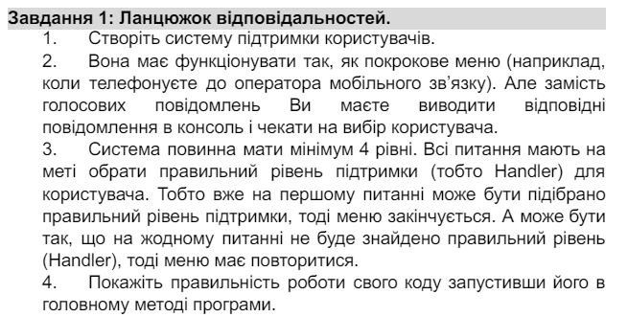

**Код:** using System;

public class SupportHandler

{

private SupportHandler nextHandler;

public SupportHandler SetNextHandler(SupportHandler handler)

{

nextHandler = handler;

return handler;

}

public virtual void HandleRequest(string request)

{

if (nextHandler != null)

{

nextHandler.HandleRequest(request);

}

else

{

Console.WriteLine("Sorry, we cannot resolve your issue at this level.");

}

}

}

public class LevelOneSupport : SupportHandler

{

public override void HandleRequest(string request)

{

if (request == "level1")

{

Console.WriteLine("Your issue is being resolved at Level One Support.");

}

else

{

base.HandleRequest(request);

}

}

}

public class LevelTwoSupport : SupportHandler

{

public override void HandleRequest(string request)

{

if (request == "level2")

{

Console.WriteLine("Your issue is being resolved at Level Two Support.");

}

else

{

base.HandleRequest(request);

}

}

}

public class LevelThreeSupport : SupportHandler

{

public override void HandleRequest(string request)

{

if (request == "level3")

{

Console.WriteLine("Your issue is being resolved at Level Three Support.");

}

else

{

base.HandleRequest(request);

}

}

}

public class LevelFourSupport : SupportHandler

{

public override void HandleRequest(string request)

{

if (request == "level4")

{

Console.WriteLine("Your issue is being resolved at Level One Support.");

}

else

{

base.HandleRequest(request);

}

}

}

class Program

{

static void Main(string[] args)

{

SupportHandler level1 = new LevelOneSupport();

SupportHandler level2 = new LevelTwoSupport();

SupportHandler level3 = new LevelThreeSupport();

SupportHandler level4 = new LevelFourSupport();

level1.SetNextHandler(level2).SetNextHandler(level3).SetNextHandler(level4);

string request = "";

while (request != "exit")

{

Console.WriteLine("Please enter your support request (level1, level2, level3, level4), or 'exit' to quit:");

request = Console.ReadLine();

level1.HandleRequest(request);

}

}

}

**Результат:**

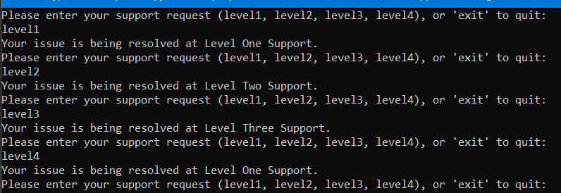

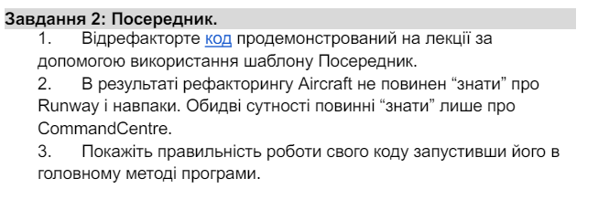**Код:** using System;

using System.Collections.Generic;

namespace DesignPatterns.Mediator

{

class CommandCentre

{

private List<Runway> _runways = new List<Runway>();

private List<Aircraft> _aircrafts = new List<Aircraft>();

public CommandCentre()

{

}

public void AddRunway(Runway runway)

{

_runways.Add(runway);

}

public void AddAircraft(Aircraft aircraft)

{

_aircrafts.Add(aircraft);

}

public void RequestLanding(Aircraft aircraft)

{

foreach (var runway in _runways)

{

if (!runway.CheckIsActive())

{

aircraft.Land(runway);

return;

}

}

Console.WriteLine($"All runways are busy. {aircraft.Name} cannot land at the moment.");

}

public void RequestTakeoff(Aircraft aircraft)

{

foreach (var runway in _runways)

{

if (runway.IsBusyWithAircraft == aircraft)

{

aircraft.TakeOff(runway);

return;

}

}

Console.WriteLine($"{aircraft.Name} cannot take off. It is not on any runway.");

}

}

class Runway

{

public readonly Guid Id = Guid.NewGuid();

public Aircraft? IsBusyWithAircraft;

public bool CheckIsActive()

{

return IsBusyWithAircraft == null;

}

public void HighLightRed()

{

Console.WriteLine($"Runway {Id} is busy!");

}

public void HighLightGreen()

{

Console.WriteLine($"Runway {Id} is free!");

}

}

class Aircraft

{

public string Name { get; }

public Aircraft(string name)

{

Name = name;

}

public void Land(Runway runway)

{

Console.WriteLine($"Aircraft {Name} is landing.");

Console.WriteLine($"Checking runway.");

if (runway.IsBusyWithAircraft == null)

{

Console.WriteLine($"Aircraft {Name} has landed.");

runway.IsBusyWithAircraft = this;

runway.HighLightRed();

}

else

{

Console.WriteLine($"Could not land, the runway is busy.");

}

}

public void TakeOff(Runway runway)

{

Console.WriteLine($"Aircraft {Name} is taking off.");

runway.IsBusyWithAircraft = null;

runway.HighLightGreen();

Console.WriteLine($"Aircraft {Name} has taken off.");

}

}

class Program

{

static void Main(string[] args)

{

CommandCentre commandCentre = new CommandCentre();

Runway runway1 = new Runway();

Runway runway2 = new Runway();

Runway runway3 = new Runway();

commandCentre.AddRunway(runway1);

commandCentre.AddRunway(runway2);

commandCentre.AddRunway(runway3);

Aircraft aircraft1 = new Aircraft("Boeing 747");

Aircraft aircraft2 = new Aircraft("Airbus A320");

commandCentre.AddAircraft(aircraft1);

commandCentre.AddAircraft(aircraft2);

commandCentre.RequestLanding(aircraft1);

commandCentre.RequestLanding(aircraft2);

commandCentre.RequestTakeoff(aircraft1);

commandCentre.RequestTakeoff(aircraft2);

}

}

}

**Результат:** 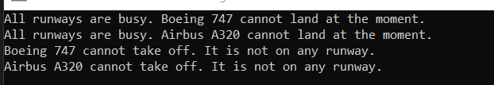

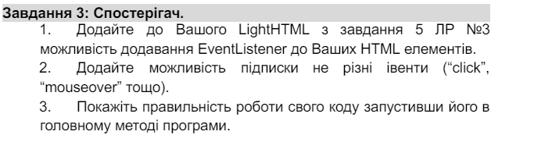**Код:** using System;

using System.Collections.Generic;

using System.Text;

public abstract class LightNode

{

public abstract string OuterHTML { get; }

public abstract string InnerHTML { get; }

public abstract void AddEventListener(string eventType, EventHandler eventHandler);

public abstract void RemoveEventListener(string eventType, EventHandler eventHandler);

}

public class LightTextNode : LightNode

{

private readonly string _text;

public LightTextNode(string text)

{

_text = text;

}

public override string OuterHTML => _text;

public override string InnerHTML => _text;

public override void AddEventListener(string eventType, EventHandler eventHandler)

{

// Текстовий вузол не підтримує події

}

public override void RemoveEventListener(string eventType, EventHandler eventHandler)

{

// Текстовий вузол не підтримує події

}

}

public class LightElementNode : LightNode

{

private readonly string _tag;

private readonly bool _blockType;

private readonly bool _selfClosing;

private readonly List<string> _classes;

private readonly List<LightNode> _children;

private readonly Dictionary<string, List<EventHandler>> _eventListeners;

public LightElementNode(string tag, bool blockType, bool selfClosing, List<string> classes, List<LightNode> children)

{

_tag = tag;

_blockType = blockType;

_selfClosing = selfClosing;

_classes = classes;

_children = children;

_eventListeners = new Dictionary<string, List<EventHandler>>();

}

public override string OuterHTML

{

get

{

StringBuilder builder = new StringBuilder();

builder.Append($"<{_tag}");

if (_classes.Count > 0)

{

builder.Append(" class=\"");

builder.Append(string.Join(" ", _classes));

builder.Append("\"");

}

builder.Append(">");

if (!_selfClosing)

{

foreach (var child in _children)

{

builder.Append(child.OuterHTML);

}

builder.Append($"</{_tag}>");

}

return builder.ToString();

}

}

public override string InnerHTML

{

get

{

StringBuilder builder = new StringBuilder();

foreach (var child in _children)

{

builder.Append(child.OuterHTML);

}

return builder.ToString();

}

}

public override void AddEventListener(string eventType, EventHandler eventHandler)

{

if (!_eventListeners.ContainsKey(eventType))

{

_eventListeners[eventType] = new List<EventHandler>();

}

_eventListeners[eventType].Add(eventHandler);

}

public override void RemoveEventListener(string eventType, EventHandler eventHandler)

{

if (_eventListeners.ContainsKey(eventType))

{

_eventListeners[eventType].Remove(eventHandler);

}

}

}

class Program

{

static void Main(string[] args)

{

var title = new LightTextNode("Welcome to My Website");

var paragraph1 = new LightTextNode("This is a simple paragraph.");

var paragraph2 = new LightTextNode("This is another paragraph.");

var listItems = new List<LightNode>

{

new LightTextNode("Item 1"),

new LightTextNode("Item 2"),

new LightTextNode("Item 3")

};

var unorderedList = new LightElementNode("ul", true, false, new List<string>(), listItems);

var bodyChildren = new List<LightNode> { paragraph1, paragraph2, unorderedList };

var body = new LightElementNode("body", true, false, new List<string>(), bodyChildren);

var htmlChildren = new List<LightNode> { title, body };

var html = new LightElementNode("html", true, false, new List<string>(), htmlChildren);

// Додамо подію click для заголовка

title.AddEventListener("click", (sender, e) => Console.WriteLine("Title clicked!"));

Console.WriteLine("Inner HTML of the page:");

Console.WriteLine(html.InnerHTML);

Console.WriteLine();

Console.WriteLine("Outer HTML of the page:");

Console.WriteLine(html.OuterHTML);

}

}

**Результат:** 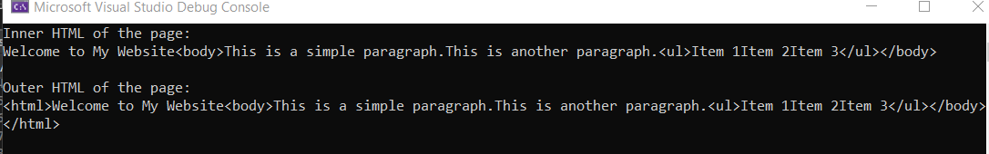

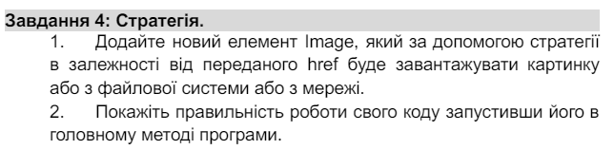**Код:**

using System;

public interface IImageStrategy

{

void LoadImage(string url);

}

public class FileSystemImageStrategy : IImageStrategy

{

public void LoadImage(string url)

{

Console.WriteLine($"Loading image from file system: {url}");

}

}

public class NetworkImageStrategy : IImageStrategy

{

public void LoadImage(string url)

{

Console.WriteLine($"Loading image from network: {url}");

}

}

public class Image

{

private readonly string _url;

private readonly IImageStrategy _strategy;

public Image(string url, IImageStrategy strategy)

{

_url = url;

_strategy = strategy;

}

public void Load()

{

_strategy.LoadImage(_url);

}

}

class Program

{

static void Main(string[] args)

{

Image fileSystemImage = new Image("path/to/image.jpg", new FileSystemImageStrategy());

fileSystemImage.Load();

Image networkImage = new Image("http://example.com/image.jpg", new NetworkImageStrategy());

networkImage.Load();

}

}

**Результат:**



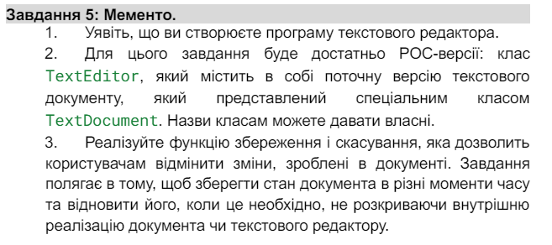**Код:** using System;

using System.Collections.Generic;

public class TextDocument

{

public string Content { get; set; }

public TextDocument(string content)

{

Content = content;

}

public TextDocumentMemento CreateMemento()

{

return new TextDocumentMemento(Content);

}

public void RestoreMemento(TextDocumentMemento memento)

{

Content = memento.Content;

}

}

public class TextDocumentMemento

{

public string Content { get; }

public TextDocumentMemento(string content)

{

Content = content;

}

}

public class TextEditor

{

private readonly Stack<TextDocumentMemento> _mementos = new Stack<TextDocumentMemento>();

private readonly TextDocument _document;

public TextEditor(TextDocument document)

{

_document = document;

}

public void Save()

{

_mementos.Push(_document.CreateMemento());

Console.WriteLine("Document state saved.");

}

public void Undo()

{

if (_mementos.Count > 0)

{

var memento = _mementos.Pop();

_document.RestoreMemento(memento);

Console.WriteLine("Undo successful.");

}

else

{

Console.WriteLine("No previous states to undo.");

}

}

public void DisplayDocument()

{

Console.WriteLine("Current document content:");

Console.WriteLine(_document.Content);

}

}

class Program

{

static void Main(string[] args)

{

var document = new TextDocument("Initial document content.");

var editor = new TextEditor(document);

editor.DisplayDocument();

editor.Save();

document.Content = "Modified document content.";

editor.DisplayDocument();

editor.Undo();

editor.DisplayDocument();

}

}

**Результат:**

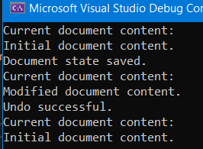

**Висновок:** У ході виконання лабораторної роботи я навчився реалізовувати структурні шаблони проєктування Ланцюжок відповідальностей, Посередник, Спостерігач, Стратегія, Мементо